TP80 fast Picker robot
The TP80 fast Picker is an extremely fast robot dedicated to handling operations of small parts (under 1 kg). It is particularly well-suited for packaging applications in various fields such as food, pharmaceutical, photovoltaics or cosmetics.
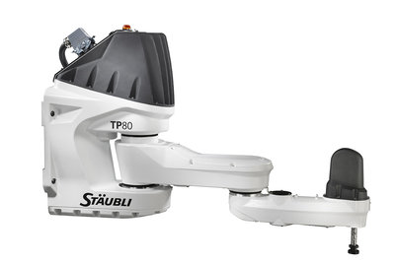

Main product benefits

High speed
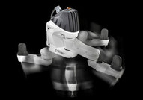
Extremely fast robot with sustained 200 picks per minute (ppm) capability.

Simple mounting
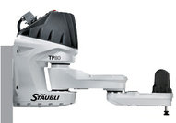
The TP80 fast Picker can be mounted on a much lighter base than parallel robots, bringing substantial cost savings and making it easier to integrate in a cell.

High precision and rigidity
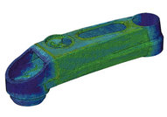
The sturdy industrial design of the TP80 makes very repeatable throughout its work envelope.

Large work envelope
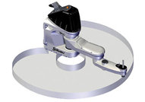
Its 800 mm reach with 100 mm stroke enables the TP80 to cover a large work envelope while maintaining high speed.

No arm interference when used with vision
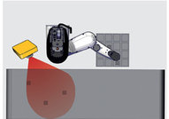
Unlike parallel robots with their multi-arm design, the TP80 does not interfere with the line of vision of the camera.

Slim forearm
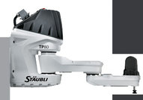
Its slim forearm enables the robot to access confined areas, for example slotted machine openings.

All user cables running inside the arm
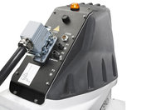
Electrical, pneumatic and I/O connections are available on the tool flange with all cables running inside the arm.

High protection
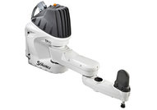
IP65 rating (with optional bellows) and angled connector design bring better protection against dust and liquids.

Main characteristics
Model | TP80
Number of degrees of freedom | 4
Maximum load capacity * | 1 kg
Nominal load capacity | 0,5 kg
Reach | 800 mm
Repeatability | ±0,05 mm
Stroke | 100 mm
Protection class (with optional bellows*) | IP54 (IP65*)
Attachment methods | Wall
Stäubli CS8 series controller | CS8C
* Under specific configuration, consult Stäubli.

